Our ecological footprint
How far can we go?
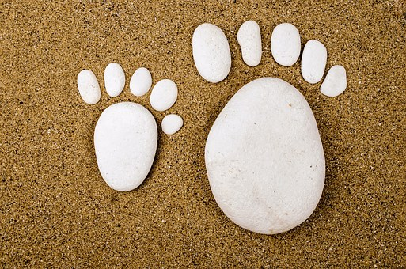
How many earthes do we need?
It is time for a change now!
Climate change-how nice, that’s what many people say. It is getting warmer from summer to summer and we don’t need to go on holiday far away.
But we know that climate change is very dangerous for people and animals.
Animals are loosing their natural environment. The weather is changing, there are more meteorological disasters coming closer and closer like the one in Bützow two years ago which destroyed many buildings in the city. So we are worried and want to change something now.
This week we want to find out:
-What is an ecological footprint?
-How can we young people have an influence on it?
After working on that topic we know:
-There are things we can do likeabout food or things at home.
-The German recycling system is very good. It is quite normal for most people to carry bottles back to
the shops or containers, to collect paper for recycling. We should care more about that at school.
-Most of us walk to school or go by bus. Only some come by car because it is on their parents way to
work. What about later when we have jobs far away? We hope that we can do car sharing.
-Many of us have already started to think about eating meat. Our Green kitchen story project helps
us to create lots of ideas.
- It is quite normal for us to turn off the heating at night or to switch off the light when we leave the
room.

